**Report Development using SQL Server**

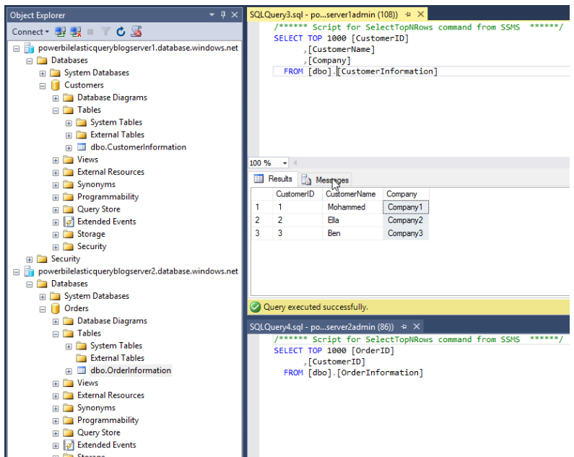

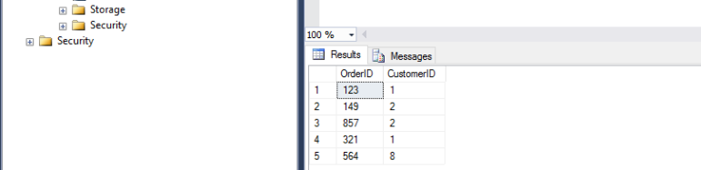

Once the databases and tables are set up, the steps to set up an external table in the Orders database are as follows:

1. Create a master key and scoped credential in the Orders database, using the credentials for the Customers database.

|  |  |
| --- | --- |
|  | CREATE MASTER KEY ENCRYPTION BY PASSWORD = '<password>'; |
|  | CREATE DATABASE SCOPED CREDENTIAL ElasticDBQueryCred |
|  | WITH IDENTITY = '<username>', |
|  | SECRET = '<password>'; |

[**view raw**](https://gist.github.com/AliceWaddicor/9721c0bc1e1c08610751e9321a808c11/raw/899a35b6e7a960bb363bd8e75daa5c238741b7bd/Create%20master%20key%20and%20scoped%20credential.sql)[**Create master key and scoped credential.sql**](https://gist.github.com/AliceWaddicor/9721c0bc1e1c08610751e9321a808c11#file-create-master-key-and-scoped-credential-sql) hosted with  by [**GitHub**](https://github.com/)

2. Create an external data source using the credential created above

|  |  |
| --- | --- |
|  | CREATE EXTERNAL DATA SOURCE MyElasticDBQueryDataSrc WITH |
|  | (TYPE = RDBMS, |
|  | LOCATION = <server location>, |
|  | DATABASE_NAME = 'Customers', |
|  | CREDENTIAL = ElasticDBQueryCred, |
|  | ); |

[**view raw**](https://gist.github.com/AliceWaddicor/7c97d94b3272e62ed678e82b0cda7951/raw/4b5828c607e93013ab7f87607e1ab33a9901b6d4/Create%20external%20data%20source.sql)[**Create external data source.sql**](https://gist.github.com/AliceWaddicor/7c97d94b3272e62ed678e82b0cda7951#file-create-external-data-source-sql) hosted with  by [**GitHub**](https://github.com/)

Location should be the full server location e.g. ‘MyServer.database.windows.net’.

3. Create an external table in the Orders database, which has the same schema as the CustomerInformation table in the Customers database.

|  |  |
| --- | --- |
|  | CREATE EXTERNAL TABLE [dbo].[CustomerInformation] |
|  | ( [CustomerID] [int] NOT NULL, |
|  | [CustomerName] [varchar](50) NOT NULL, |
|  | [Company] [varchar](50) NOT NULL) |
|  | WITH |
|  | ( DATA_SOURCE = MyElasticDBQueryDataSrc) |

[**view raw**](https://gist.github.com/AliceWaddicor/45c46dee2deff97656cd6ac0ca07cfb4/raw/deb42f1cd3110ec5d2a14e36c26519f70ea8a22e/Create%20external%20table.sql)[**Create external table.sql**](https://gist.github.com/AliceWaddicor/45c46dee2deff97656cd6ac0ca07cfb4#file-create-external-table-sql) hosted with  by [**GitHub**](https://github.com/)

If a table with the same name existed already in the Orders database, you’d have to give it a different name..

These steps let you access the data in the CustomerInformation table in the Customers database as if it were a table in the Orders database.

[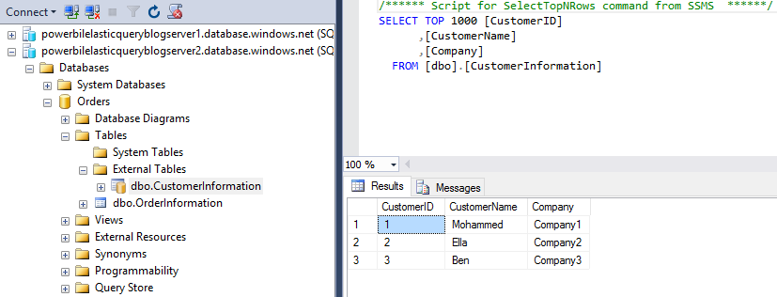](https://blogs.endjin.com/wp-content/uploads/2017/01/Data-from-external-table.png)